Pathomechanism of Diabetic Foot Ulcer Healing from the Combined Use of Platelet Rich Fibrin and Hyaluronic Acid

Ronald W. Kartika¹, Idrus Alwi², Franciscus D. Suyatna ³, Em Yunir², Sarwono Waspadji², Suzzana Immanuel^{4,} Todung Silalahi ⁵, Saleha Sungkar⁶, Jusuf Rachmat⁷, Saptawati Bardosono ⁸, Mirta Hediyati Reksodiputro ⁹*

¹Doctoral Program in Medical Science Faculty of Medicine Universitas Indonesia
²Department of Internal Medicine, Faculty of Medicine Universitas Indonesia – Cipto Mangunkusumo Hospital, Jakarta,
Indonesia
³Department of Clinical Pharmacology, Faculty of Medicine Universitas Indonesia, Jakarta, Indonesia
⁴Department of Clinical Pathology, Faculty of Medicine Universitas Indonesia – Cipto Mangunkusumo Hospital, Jakarta,
Indonesia.
⁵Department of Internal Medicine, Krida Wacana Christian University, Jakarta, Indonesia.
⁶Department of Clinical Parasitology, Faculty of Medicine Universitas Indonesia, Jakarta, Indonesia
⁷Department of Thoracic Cardiac and Vascular Surgery, Faculty of Medicine Universitas Indonesia, Jakarta, Indonesia
⁸Department of Nutrition, Faculty of Medicine Universitas Indonesia, Jakarta, Indonesia
⁹Facial Plastic Reconstructive Division, Department of Otorhinolaryngology, Faculty of Medicine, Universitas
Indonesia, Cipto Mangunkusumo Hospital, Jakarta, Indonesia (Corresponding author )
Emails: citamirta@yahoo.com

Abstract:
Background : The current standard management of diabetic foot ulcers (DFUs) consists of surgical debridement followed by frequent dressing changes with tight infection and glycaemic control. Recently, the use of autologous platelet-rich fibrin (PRF) has emerged as an adjunctive method for the treatment of DFUs. This study aims to evaluate the role of combination of A-PRF + hyaluronic acid (HA) for the treatment of DFUs.
Methods : This open-label randomized controlled trial was conducted at Koja District Hospital and Gatot Soebroto Hospital from July 2019 to April 2020. DFU patients with a wound duration of three months, Wagner-2, with an ulcer size less than 40 cm² were included in the study. Subjects were taken based on the rule of thumb and divided randomly into three groups, namely topical A-PRF + AH, A-PRF and 0.9% Sodium Chloride as a control, each of 10 subjects. Biomarkers (e.g., VEGF and IL-6) were examined from the DFUs by cotton swab and analysed using an ELISA. Biomarkers and the granulation index were checked on days 0, 3, and 7. Data were analysed using SPSS version 20 software with an ANOVA and Kruskal Wallis test to compare the effects of angiogenesis and inflammation in the three groups. The granulation index was measured using ImageJ.
Result : Topical therapy with A-PRF + AH was associated with a significant increase in VEGF from day 0 (232.8 pg/mg protein) to day 7 (544.5 pg/mg protein) compared to A-PRF on day 0 (185.7 pg/mg protein) to day 7 (272.8 pg/mg protein), and the controls on day 0 (183.7 pg/mg protein) to day 7 (167.4 pg/mg protein). In the A-PRF + AH group, there was also a significant decrease in IL-6 from day 0 (106.4 pg/mg protein) to day 7 (88.7 pg/mg protein) compared with PRF on day 0 (91.9 pg/mg protein) to day 7 (48,8 pg/mg protein). In contrast, IL-6 was increased in the control group from day 0 (125.3 pg/mg protein) to day 7 (167.9 pg/mg protein).
Conclusion: The combination of PRF + HA can increase angiogenesis (VEGF) and reduce pro inflammation (IL-6) in DFUs. A-PRF + HA may represent a new therapeutic method for DFU.

Keywords: diabetic foot ulcer; platelet-rich fibrin; hyaluronic acid

1. INTRODUCTION
The development of holistic treatment of diabetic foot ulcers (DFU) has evolved in the last decade since it was found that topical therapies with biologically effective ingredients were found. The provision of supplementary therapy with growth factors has been shown to be beneficial for the treatment of DFU in addition to standard treatment with debridement, vascular control and infection. The main problem with DFU is that it takes longer to heal than other wounds. One of the contributing factors is chronic inflammation where high levels of matrix metalloproteinases (MMPs) significantly contribute to delayed healing.³ These inflammatory cells release cytokines including interleukins (IL1, IL6) and tumor necrosis factor-α (TNF-α) which will cause chronic inflammation.⁴
⁴
The presence of a neuro-ischemic condition in DFU results in reduced oxygen and nutrient delivery to the wound which leads to impaired wound healing. Due to lack of oxygen and nutrients, endothelial cells are unable to express growth factors that play a role in wound healing, such as vascular endothelial growth factor (VEGF) and platelet-derived growth factor (PDGF).⁵
Almost all of the cells at the wound will influence the metabolism and activity such as decrease the level of growth factor that will delay the healing process.⁶
Platelet-rich fibrin (PRF) has been used as a therapeutic supplement in the treatment of wounds in the field of oral surgery.7 Autologous PRF gels contain cytokines, growth factors, chemokines, and fibrin scaffolds that originate from the patient's blood.7,8 Alpha granules are present in platelets contains many growth factors including PDGF, VEGF and transformation growth factor-β (TGF- β) which functions to stimulate cell proliferation and differentiation to form new tissue.⁷ This will induce molecular and cellular responses to normal wound healing.
In the last decade, PRF has been developed to Advance Platelet Rich Fibrin (A-PRF) which has more growth factors resulting faster and better wound healing.⁹
The patient of DFU has low growth factor and prolonged inflammation, so to optimize growth factor release and control the inflammation, hyaluronic acid (HA) is added to A-PRF.¹⁰
HA is a glycosaminoglycan that could enhance angiogenesis, wound healing and reduces chronic inflammation in DFU.¹¹ However, combination of A-PRF+HA has not been used in the treatment of DFU, so it is necessary to do research to find out the effect of combination of A-PRF and HA in the treatment of DFU.

2. METHODS. We conducted an open label randomized controlled trial on July 2019 to April 2020. Informed consent was obtained from patients including the use of photographs (ImageJ). The study has been approved by The Ethics Committee of the Faculty of Medicine Universitas Indonesia ID 0855/UN2.F1/ETIK/2018.
The study was conducted in Koja District Hospital and Gatot Soebroto Hospital, Jakarta. Diabetic patients with chronic foot ulcer (DFU), with an average wound duration of three months, categorized as Wagner 2, ulcer large less than 40 cm² were included in the study. All patients had blood sugar under control with oral antidiabetic in the range of 150 - 200 mg/dl. HbA1c range was 6 - 7.5 mg/dl. Patients with the following criteria were excluded: platelet dysfunction syndrome, critical thrombocytopenia, unstable hemodynamic and pregnancy.
Patients who had come to the diabetes clinic and met the inclusion criteria were taken peripheral venous blood to get A-PRF. In the A-PRF + HA group, HA was added according to the study protocol. Gel A-PRF + HA and A-PRF were used as topical therapy in DFU. The parameters of the study were swab biomarkers of VEGF and IL-6 and image evaluation on wounds before treatment and on days 3, 7.

2.1 A-PRF and A-PRF+HA Preparation
To make A-PRF gel we used autologous 20-40 mL venous blood in non anticoagulant tube, then centrifuge 200 G for 8 minutes resulting fibrin, buffy coat, erythrocytes.
Erythrocytes layer was carefully removed from above the buffy coat and fibrin with a sterile scissor and transferred to a new sterile tube. A-PRF was formed by fibrin and buffy coat, in which platelet (rich growth factor and cytokine) was entrapped in the fibrin.
To make homogenous A-PRF+HA gel, 1 mL A-PRF was mixed with 0.6 mL HA 0,2% using a vortex machine around 20 seconds.

2.2 Wound treatment and monitoring
In this study, the subject divided into 3 groups: A-PRF+HA, A-PRF and 0,9% sodium chloride (NaCl) as control.
Every topical application the amount of gel was depend of ulcer large.Topical A-PRF or A-PRF+HA is used for ulcer large 10 cm² and covered by a protective bandage. The same condition was also done every three days.
In monitoring wound healing, swab of biomarker did before clean the wound every patient control. In addition to biomarker evaluation, clinical wound development is carried out by looking at the granulation of the area and the epithelialization of the wound (wound area).
The wounds were photographed before and after treatment using a digital camera. The wound and granulation area was identified using ImageJ assessment software. Granulation index is used as an indicator of granulation growth on wound area which measured by ImageJ software.

Biomarker of Wound Healing Evaluation
To identify the process of angiogenesis and condition in DFU healing, VEGF and IL-6 biomarker was taken by cotton swab using sterile cotton gauze and rotated on the wound in the central area until the gauze is wet cotton from DFU surface before topical therapy.
From the wound fluid that is caught on a cotton swab, it is placed in an aliquote tube containing NaCl buffer and sent to an integrated laboratory. The material obtained is in a 1500 G centrifuge to obtain lysate and is examined for VEGF and IL-6 with an Elisa Reader.

The data were analysed using SPSS version 20. The association between variables was tested by anova and Kruskal Wallis.
3. RESULTS
We recruited 30 subjects consist of 12 men and 18 women. The median age of women was 64 years and men 61 years. The subjects were divided into three groups (A-PRF+HA, PRF and control) randomly; 10 subjects for each group.

Table 1. Characterictic Subject Base On Interventrion

Characteristic | A-PRF+AH  (n = 10) |  | A-PRF  (n = 10) | Control  (n = 10) |  | p
Age (year)ª |  | 59.8 (SD 12.7) | 64.7 (SD 12.0) |  | 62.9 (SD 13.2) |  | 0.626
Sex. n (%)  Male  Female |  | 5/10  5/10 | 4 (40)  6 (60) |  | 3 (30)  7 (70)
BMIª |  | 28.9 (SD 2.7) | 27.3 (SD 2.08) |  | 28.4 (SD 2.5) |  | 0.337
Hemoglobin (g/dL) |  | 12.7 (27.4−39.0) | 13.1 (SD 1.3) |  | 12.05 (10.1−16.5) |  | 0.224
Hematocrite(%) |  | 34.1 (SD 4.3) | 35.4 (SD 4.9) |  | 33.5 (SD 6.4) |  | 0.145
Leucosit (10³/µl) ª |  | 13.30 (SD 1.08) | 11.08 ( SD1.33) |  | 9.23 (SD 1.66) |  | 0.985
Platelet (10³/µl) ª  Random Blood  Glucosa. mg/dL^{b} |  | 354.9 (SD 167.5)  286.0 (170−390) | 338.8 (SD 164.5)  243.8 (SD 47.4) |  | 319.9 (SD 128.4)  254.7 (SD 58.6) |  | 0.880  0.104
HbA1C (%)ª  Cholesterol total  (mg/dL) |  | 11.34 (SD 1.30)  214.5 (SD16.9) | 9.0 (SD 0.68)  249.3 ( SD 16.1) |  | 8.5 (SD 0.72)  202.3 (SD 38.6) |  | 0.950  0.096
Albumin (mg/dL) |  | 3.3 (2.8–4.2) | 3.1 (2.8–4.2) |  | 3.2 (SD 0.39) |  | 0.662
ªmean (SD), anova test
^{b}median (min-max), Kruskal Wallis test

3.1. Biomarker output
Table 2 shows the level of VEGF that collected from DFU swab. On baseline, the VEGF levels were not significant difference among the three groups, meaning that the data was homogenous.
Evaluation on day-3 and day-7 days shows significant increase on VEGF levels in the A-PRF+HA group compared with PRF and controls.
On day-3 the VEGF level increase in the A-PRF+HA group (232.8 pg/mg to 320.6 pg/mg) and on day-7 (232.8 pg/mg to 544.5 pg/mg). In PRF group, there is a decrease of VEGF level on day-3 (185.7 pg/mg to 180.4 pg/mg) and but an increase day-7 (185.7 pg/mg to 272,8 pg/mg). In control group there is also a decrease of VEGF level on day-3 (183.7 pg/mg to 144.8 pg/mg) and day-7 (183.7 pg/mg to 167.4 pg/mg).

Figure 1. shows the ∆ VEGF based on the interventions. The delta of VEGF levels in A-PRF+HA group increase: ∆ 0−3 (43.1 pg/mg), ∆ 3-7 (145.9 pg/mg) and ∆ 0−7 (275.8 pg/mg).
In A-PRF group, there is increase ∆ 0−3 (1.8 pg/mg), ∆ 3-7 (99.9 pg/mg) and ∆ 0−7 (104.7 pg/mg). In control group, there is decrease ∆ 0−3 (4.9 pg/mg) and increase ∆ 3-7 (30.1 pg/mg) and ∆ 0−7 (28.3 pg/mg)
In group A-PRF+HA there is an increase of ∆ VEGF compared to the PRF and control group on day-3 (p = 0.003), and on day-7 (p < 0,001).

Table 2. Mean of VEGF swab DFU base on intervention
Intervention | A-PRF+HA  Mean (SD) | A-PRF  Mean (SD) | Control  Mean (SD) | Anova p
Day-0 | 232,8 (125,7) | 185,7 (100,8) | 183,7 (127,2) | 0,568
Day-3 | 320,6 (165,8) | 180,4 (87,4) | 144,8 (87,7) | 0,022
Day-7 | 544,5 (266,8) | 272,8 (97,7) | 167,4 (98,8) | 0,001
Post-hoc anova test:
A-PRF +HA increase significantly compare with control on day-3(p=0,003) and on day-7 (p<0,001) A-PRF +HA increase significantly compare with A-PRF on day-3 (p = 0,014) and on day-7 (p=0,002) A-PRF increase not significantly compare with control on day -3 (p = 0,612) and on day -7 (p=0,186) 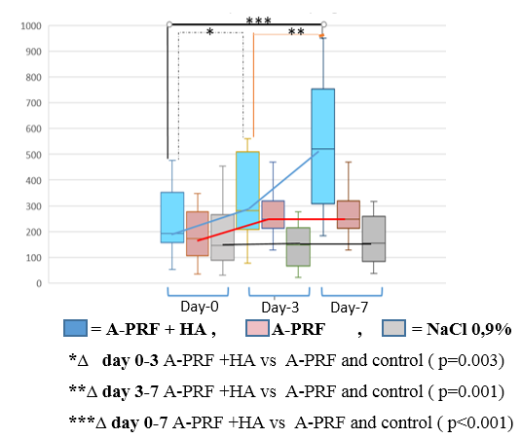
pg/ mg protein

Figure 1. The Increasing ∆ VEGF based on intervention

After interventions (Table 3) there was a decrease in IL-6 for the A-PRF+HA group on day-3 (106.4 pg/mg to 99.5 pg/mg) and day-7 (106.4 pg/mg to 88.7 pg/mg). In PRF group on day-3 (91.9 pg/mg to 72.8) and on day-7 (91.9 pg/mg to 42.8 pg/mg). In the PRF group IL-6 levels decrease on day-3 (91.9 pg/mg to 72.8 pg/mg) and on day-7 (91.9 pg/mg to 4 pg/mg). In the control group IL-6 levels increase on day-3 (125.3 pg/mg to 131.1 pg/mg) and on day-7 (125.3 pg/mg to 167.9 pg/mg). IL-6 in the A-PRF+HA group decreased significantly compared with A-PRF and controls on day-7 (p = 0.041).

Table 3. Mean of IL-6 swab DFU base on intervention
Intervention | A-PRF+HA  median  (min-max) | A-PRF  median (min-max) | Control  median  (min-max) | p
Day-0 | 106.4 (83.1−407.6) | 91.9(38.6−151.6) | 125.3 (20.3−287.0) | p=0.287
Day-3 | 99.5(76.3-102.2) | 72.8 (27.1−148.9) | 131.1 (5.3−337.5) | p=0.141
Day-7 | 38.7 (24.3−117.9) | 48.8 (27.7-156.2) | 167.9 (27.7−156.2) | p=0.041*
(min-maks). Kruskal Wallis test
* significant decrease of IL-6 in A-PRF+AH compare with A-PRF and control on day-7
A-PRF+AH decrease significantly compare with A-PRF on day-7 (Mann Whitney test. p=0.023). . A-PRF+AH decrease significantly (Mann Whitney test) compare with control on day-3 (p=0.049) and day-7 (p=0.041)

Figure 2. shows the ∆ IL-6 based on the interventions. In A-PRF+HA group, there is a decrease in ∆ 0−3 (6.9 pg/mg), ∆ 3-7(60.8 pg/mg) and ∆ 0−7 (67.7 pg/mg). In A-PRF group, there is decrease ∆ 0−3 (3.7 pg/mg), ∆ 3-7 (0.9 pg/mg) and ∆ 0−7 (7.8 pg/mg). In control group, there is decrease ∆ 0−3 (4.3 pg/mg) and increase ∆ 3-7 (32.3 pg/mg) and ∆ 0−7 (35.5 pg/mg),
In group A-PRF+HA, Kruskal Wallis test shows a decrease in ∆ IL-6 compared with the PRF and control group on day-3 (p=0.018), and on day-7 (p=0.015).
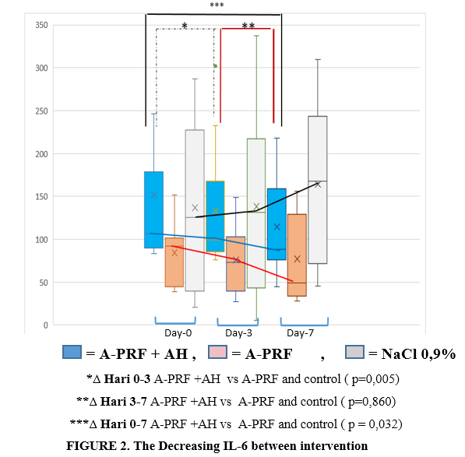
pg/mg protein

3.2 Clinical outcomes
Table 4 showed that in A-PRF+HA group the granulation index increase significantly compare with A-PRF and control on day-3 and day-7 .
Table 4 Mean of Granulation Index Base on Intervantion
Waktu  Intervensi | A-PRF + AH  (n = 10) | A-PRF  (n = 10) | Control NaCl  (n = 10) | p
Befere treatment | 42,1 ( 18,4−57,6) | 34,8 (14,1−58,9) | 35,9( 16,1−52,6) | 0,910
Day-3 | 62,3 (33,6−81,3) | 47,6 (20,5 − 73,0) | 51,3 (30,4−64,2) | 0,048
Day-7 | 78,9 (65,8−95,8) | 64,6 (37,2−89,9) | 66,0 (43,6−96,4) | 0,012
Day-14 | 97,7 ( 89,4−99,6) | 91,2 (46,0−98,9) | 78,7 (72,2−98,4) | < 0,001
Mean (SB), anova test
Post hock anova test, A-PRF + AH vs A-PRF day-3 (p = 0,043 ), day-7 (p = 0,049) and day -14 (p = 0,041),
A-PRF + AH vs control day-3 (p = 0,034), day-7 (p = 0,002), and day-14 (p < 0,001).
A-PRF vs control day-3 (p = 0,940) day-7 (p = 0,650) and day -14 (p = 0,034)

Post Hoc Anova test was shown in the figure 1.
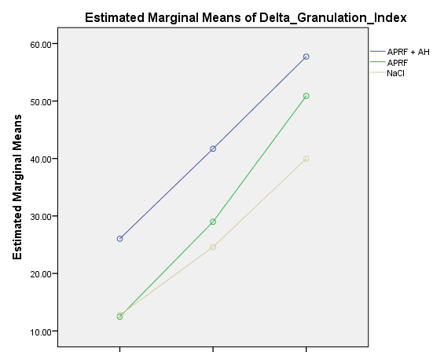
P< 0.001 ^{b}
p= 0.041 ª
HA
Δ Day-3−0 Δ Day-7−0 Δ Day-14−0
p= 0.002 ^{b}
p= 0.049 ª
p =0.043 ª
p =0.034 ^{b}

ª ΔGI of A-PRF+AH compare with A-PRF group.
^{b} ΔGI of A-PRF+AH compare with control group

Figure 1. Granulation Index (GI) base on different intervention

4. DISCUSSION
The use of topical A-PRF+HA induced the formation of healthy granulation tissue and allowed successful granulation area of the wound. Improvement of granulation tissue ( day 0 – 7) because A-PRF works synergistically with HA in increasing significantly delta VEGF ( angiogenesis). There is increase of VEGF in A-PRF+HA group compare with PRF and control group. In addition, the combination A-PRF+HA reduce inflammation compare others group which is marked by decreasing significantly of IL-6

4.1 Growth Factor Released from A-PRF. . Diabetes Type 2 is often associated with chronic hyperglycemia which can lead to dysregulation of DFU healing growth factors. Changes in growth factors contribute to tissue pathology, such as fibrosis disorders, persistent inflammation or a combination of both.13 In DFU healing, the growth of granulation tissue is influenced by the formation of new blood vessels (angiogenesis) which also functions to provide oxygen and nutritional support to new tissues. The angiogenesis process is stimulated by VEGF, bFGF, and TGF-β. The growth factor released from the platelet concentrate of non-diabetic patients is PDGF-AA followed by PDGF-BB. TGFB1. VEGF. and PDGF-AB. ¹⁴
In patients with DFU, in addition to a decrease in VEGF-A there is a decrease in the level of the VEGF-2 receptor (VEGFR-2) on the wound surface. For this reason, topical biological treatment is needed to increase the accretion of VEGFR-2 with the addition of topical growth factors, in this case A-PRF.¹⁵
Other study¹⁵ showed significant higher levels of VEGF-A and FGF-2 and lower sVEGF-R2 concentration in patients with T2DM compared to healthy subjects. There is a decreased level of VEGF-A and elevated levels of FGF-2 in patients with DM complicated DFU compared to diabetic patients without DFU.¹⁶
In this study, VEGF detected from cotton swabs came from endogenous growth factors (production of keratinocytes and fibroblasts on the wound surface itself) and exogenous (from granula α in PRF). Alpha granule in platelets trapped in fibrin will release growth factors. especially VEGF. In invitro study. some growth factors (PDGF, VEGF, TGF β) incubated in DMEM medium, were able to survive in 14 days of observation with a peak on day-7. ¹⁷ The addition of HA to PRF increase the release rate of VEGF because VEGF released from PRF will adhere to the HA surface and released slowly on the DFU surface. Attaching VEGF to DFU will stimulate endothelial cells to occur angiogenesis and stimulate the formation granulation tissue.18 Furthermore, In several studies, the A-PRF formulation with low speed and low time during the centrifugation process, will affect the release of growth factor in a significantly higher amount when compared to traditional PRF.
The addition of HA will induce the release of growth factors from PRF so that it can work more effectively.¹⁹ Otherwise fibrin of A-PRF+HA formation helps platelet binding, where VEGF is trapped 1.5 times in fibrin compared to complete blood (p <0.01). In fibrin binding, VEGF increased at day 0 and day 14, peak at day 7, PDGF-BB increased on day 14

4.2 Ha Induces Release of Growth Factors From PRF
In this study, the combination of PRF and HA released VEGF levels in greater numbers than the other groups on day-3 and day-7. The combination of PRF and HA is one of the therapeutic options for osteoarthritis and chronic tendinopathy. PRF can stimulate the healing process of various tissues by sending various growth factors and situations released by the alpha platelet granules. In this study, adding HA to PRF increased the effectiveness of growth factor release from concentrate platelets. 19,20
HA has influenced the selective permeability of α granules of activated platelets, through transport of CD41 and delivery of bioactive molecules that will induce angiogenesis, and immunity. HA can also inhibit platelet aggregation which affects the release of growth factors
.²⁰
4.3 Combine A-PRF+HA Reduce Inflamation
To see the pathway of healing DFU through inflammation, an analysis of inflammatory biomarkers was carried out, namely IL-6. Adding HA in PRF also decrease an inflammation progress in DFU, showed by decrease of IL-6 level on day-3 and day-7. These findings that stimulatory effect of HA on growth factor decrease the inflammation progression in DFU. Expression of P selectin dramatically increased after PRF interacted with bio macromolecule complex film (HA collagen (I)/chitosan). 19 The effect of HA on CD44 will increase the TGF-β receptor which depends on MAP kinase which can facilitate the increase of TGF-β1 which is pro-inflammatory along with IL-6 and IL-8. ²¹
A-PRF+HA also affects increase polarization M1 to M2 as effect of anti-inflammation. The topical application of A-PRF+HA exerts a protective effect by decreasing the release of cytokines (IL-1β, IL-6, and TNF-α) during initial inflammation thus allowing the acceleration of the inflammatory phase previously prolonged inflammation due to hyper-lycaemia in DFU.²¹
Topical application of A-PRF+HA will bind to the ICAM-1 and VCAM-1 receptors where the binding will inhibit the prolonged response of leukocytes (lymphocytes and monocytes) so that chronic inflammation can be prevented.22 In an in vitro study, showed a synergistic effect of HA and A-PRF. The combination of HA and PRP synergizes with cartilage regeneration in OA. A-PRF + HA will reduce proinflammatory cytokines and increase the proliferation of articular chondrocytes, as well as chondrogenic differentiation via the Erk1 / 2 pathway in HA and the Smad2 / 3 pathway in PRP. ²⁴
Another mechanism of AH as an anti-inflammatory is by reducing the interstitial permeability. This mechanism has been proven by Rooney study in cases of interstitial cystitis (IC) given AH which showed a decrease in urothelial permeability of the bladder wall due to decreased cytokines due to the glycosaminoglycan layer (GAG). The combination of A-PRF + HA will reduce cell permeability so that it can prevent edema in DFU and reduce inflammation locally in wounds²⁵
The formation of granulation tissue in wound healing is strongly influenced by the formation of new blood vessels and the atmosphere of inflammation in the wound area
This is the propose mechanism of A-PRF +HA in increase Granulation in diabetic foot healing (Figure 2)
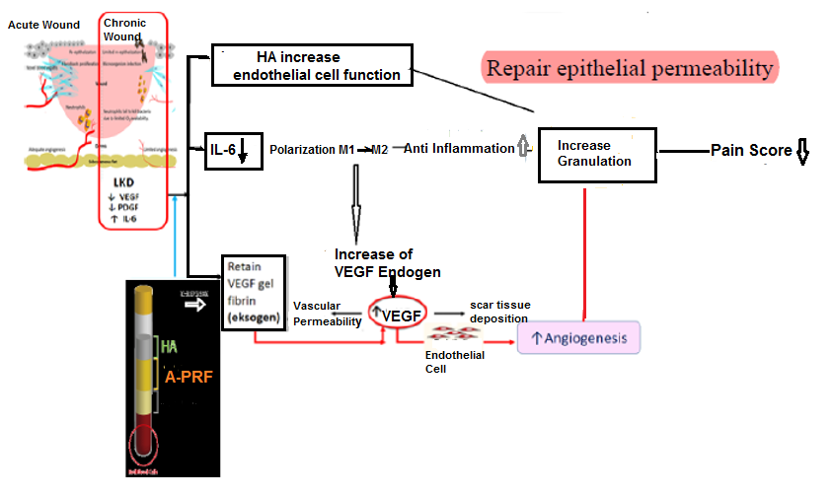
Figure 2. Propose mechanism of A-PRF +HA in increase Granulation in diabetic foot healing
5. CONCLUSION
Combination of A-PRF+HA increase angiogenesis (VEGF) and reduce inflammation ( IL-6) level on day-3 and day-7. A-PRF+HA increase granulation index through angiogenesis and anti-inflammatory pathway, thus combination of A-PRF and HA enhanced the healing effect on DFU.

REFFERENCES

1. Carvajal Am, Gluud C, Nicola S, Racines DS , Reveiz L, Olivia P . Growth factors for treating diabetic foot ulcers. Cochrane database syst re cochrane database syst rev 2015 28;(10): 548-555

2. Amstrong DG, Cohen K, Courric s, Bharara M, Marston W, Diabetic Foot Ulcers and

Vascular Insufficiency: Our Population Has Changed, but Our Methods Have not. J diabetes Sci Technol. 2011 Nov; 5(6): 1591–95

3. Muller m, Trocme C, Lardy, Morel F, Halimi S, Venhamou PY, Matrix Metalloproteinases and Diabetic Foot Ulcers: The Ratio of MMP-1 to TIMP-1 is a predictor of wound healing, Diabet Med. 2008 Apr 1; 25(4): 419–426

4. Kany S, Tilman K, Vollrath JT, Relja B, Cytokines in Inflammatory Disease, Int J Mol Sci.2019 dec; 20(23): 6008.

5. Zubair m, jamal a , role of growth factors and cytokines in diabetic foot ulcer healing: rev Endocr Metab disord , 2019 apr 20(8),1-11

6. Papanas n, maltezos e, growth factors in the treatment of diabetic foot ulcers: new

technologies, any promises? Lower extremity wounds 6(1);2007 ;37-53

7. Moraes Vy, Lenza M, Tamaoki Mj, Faloppa F, Belloti Jc. Platelet-Rich Therapies For Musculoskeletal Soft Tissue Injuries. Cochrane Database Syst Rev. 2014;29: 71-9

8. Blair P, Flaument R, Platelet α– Granules: Basic Biology And Clinical Correlates, Blood

Rev. 2009 Jul; 23(4): 77–189

9. Caruana A, Savina D, Macedo JP, Soares SC, From Platelet-Rich Plasma to Advanced -

Platelet-Rich Fibrin: Biological Achievements And Clinical Advances In Modern

Surgery, Eur J Dent. 2019 May; 13(2): 280–286
10. Raeissadat Sa, Rayegani Sm, Hassanabadi H. Knee Osteoarthritis Injection Choices:
Platelet- Rich Plasma (PRP) Versus Hyaluronic Acid (A One-Year Randomized Clinical
Trial). Clin Med Insights Arthritis Musculoskelet Disord. 2015;8:1-8.
11. Ramos-Torrecillas J, García-Martínez O, De Luna-Bertos E, Oca~Na-Peinado Fm, Ruiz C. Effectiveness Of Platelet-Rich Plasma And Hyaluronic Acid For The Treatment And Care Of Pressure Ulcers. Biol Res Nurs. 2015;17:152-158.

12. Weigek Ph, Fuller Gf , Leboeuf Rd, A Model For The Role Of Hyaluronic Acid And Fibrin In The Early Events During The Inflammatory Response And Wound Healing. J Theor Biol 1986 Mar 21;119(2):219-34

13.Sridharan Kannan, Sivaramakrishnan G, Growth Factors For Diabetic Foot Ulcers: Mixed Treatment Comparison nalysis Of Randomized Clinical Trials, J. Theor. Biol (1986) 119, 219-23.4

14. Drela E, Kulwas A, Wieslaw J, Goralczyk B , Boinska J, Drewniak W VEGF-A and PDGF-BB -Angiogenic Factors And The Stage Of diabetic foot syndrome advancement, endokrinol 2014;65(4):306-12
15.Amoli Mm, Ranjbar Sh , Roohipour N , Sayahpour Fa , Amiri P , Zahedi P, VEGF GenePolymorphism Association With Diabetic Foot Ulcer, Diabetes Research And Clinical ; 93(2011)215- 219
16.Tahergorabi Z, Khazae M, Imbalance of Angiogenesis in Diabetic Complications: The Mechanisms, Int J Prev Med. 2012 Dec; 3(12): 827–838
17 Perez AG, Rodrigues AA, Luzo AC, Lana JF. Fibrin network architectures in
pure platelet- rich plasma a characterized by fiber radius and correlated with clotting
time. J Mater Sci Mater Med. 2014;25:1967-77.

18. Pardue El, Ibrahim S, Ramamurthi A, Role Of Hyaluronan In Angiogenesis

and Its Utility To Angiogenic Tissue Engineering, Organogenesis. 2008 Oct-

Dec; 4(4): 203–214.
19. Ilio K, et al. Hyaluronic acid induces the release of growth factors from platelet-rich plasmaAsia-Pacific Journal of Sports Medicine, Arthroscopy, Rehabilitation and Technology. 2016;4: 27-32

20 Garbin LC, Olver CS, Platelet-Rich Products And Their Application To Osteoarthritis, Journal Of Equine Veterinary Science, Volume 86, March 2020

21. Ito T, Williams, Fraser DJ,Philips AO, Hyaluronan regulates transforming growth factor- β1 receptor compartmentalization, J Biol Chem, 2004 Jun 11;279(24):25326-32
22. Oertly B, Schimmer BB,Wuthrich RP, Mechanisms of hyaluronan-induced up-regulation of ICAM-1 and VCAM-1 expression by murine kidney tubular epithelial cells: hyaluronan triggers cell adhesion molecule expression through a mechanism
involving activation of nuclear factor-kappa B and activating protein-1, J
Immunol 1998 Oct 1;161(7):3431-7
23. Chen WH, Lo WC, Hsu WC.Synergistic anabolic actions of hyaluronic acid and platelet-rich plasma on cartilage regeneration in osteoarthritis therapy. Biomaterials.
2014;35:9599- 607
24. Hu Y, Wu Y, Cai J, Ma S, Wang X. The procoagulant properties of hyaluronic acid- collagen (I)/chitosan complex film. JBiomater Sci Plym Ed. 2009;20:1111-8.
- Rooney P, Srivastava A, Watson L, Quinlan LR, Pandit A. Hyaluronic acid decreases IL-6 and IL-8 secretion and permeability in an inflammatory model of interstitial cystitis. Acta Biomater. 2015;19:66−75. doi:10.1016/j.actbio.2015.02.030

