Supplementary Files Figures/ Tables
1a
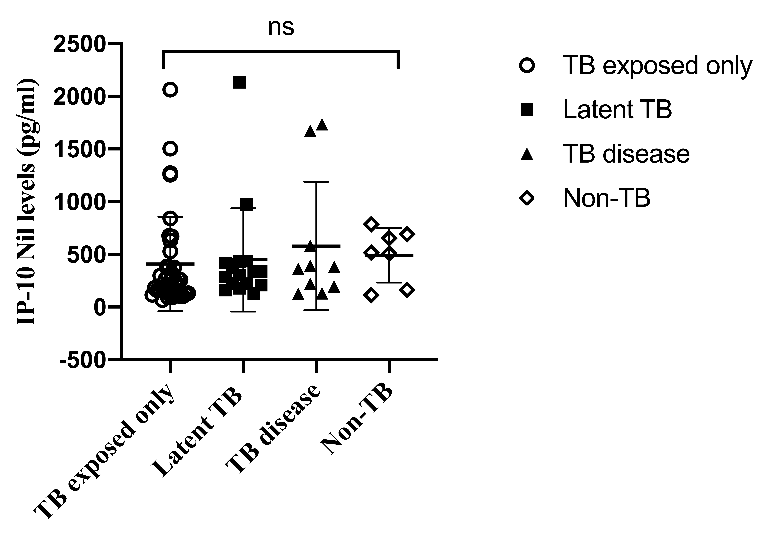

1b.
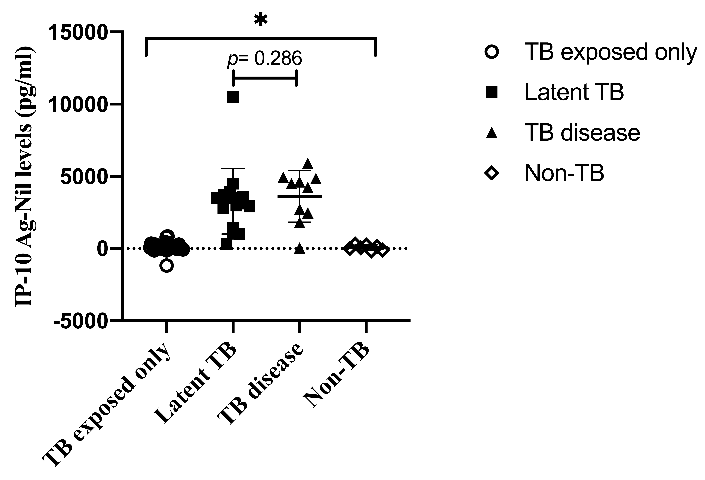
1c.
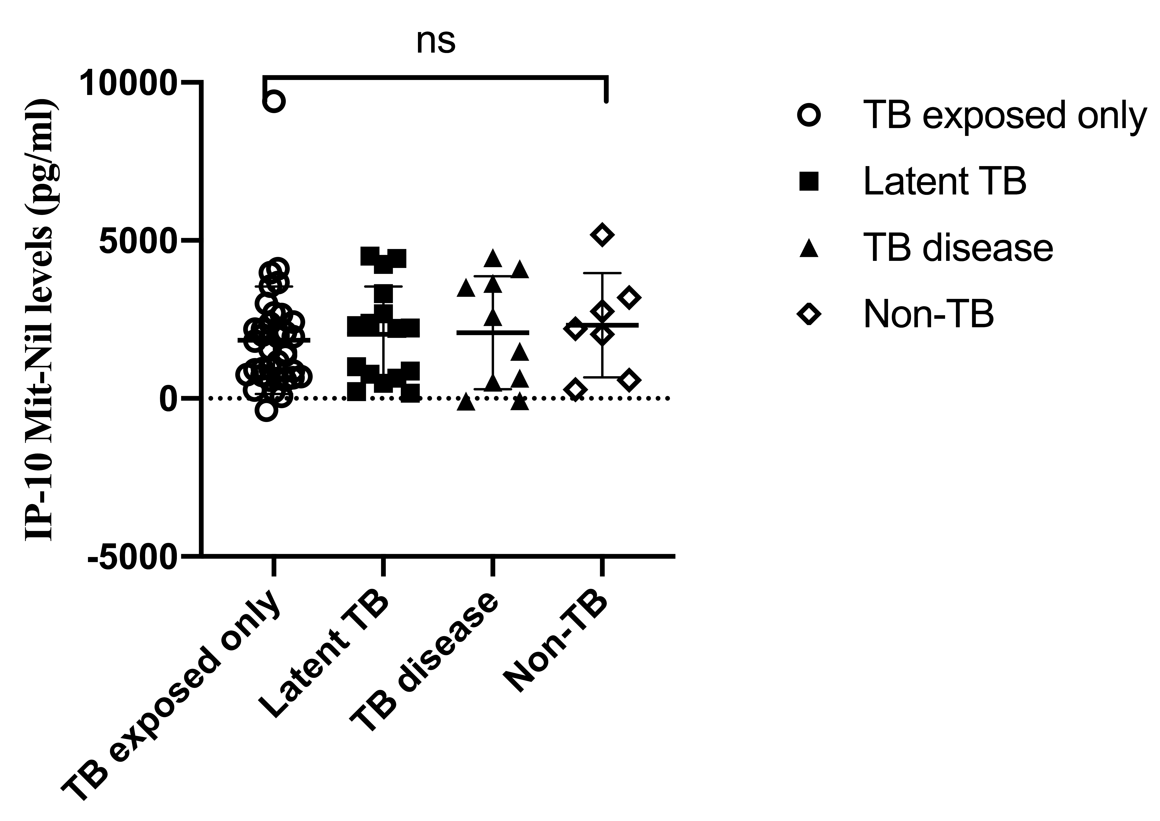
Figure 1. (a) Unstimulated (Nil) IP-10 levels, (b) antigen-stimulated (Ag-Nil) IP-10 levels, and (c) mitogen-stimulated (Mit-Nil) IP-10 levels among children with TB exposed only, latent TB, active TB, and Non TB. Horizontal lines indicate median values. IP-10= IFNγ inducible protein 10, TB= tuberculosis, ns= not significant, *p<0.05.

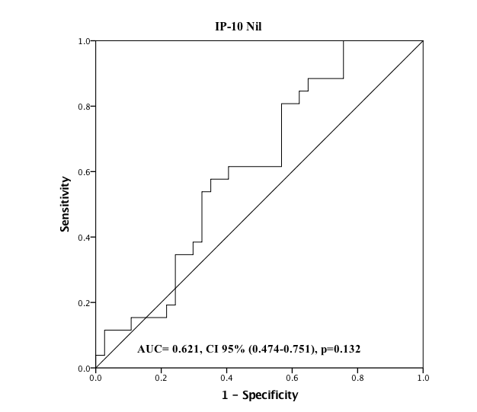
2a.
2b.
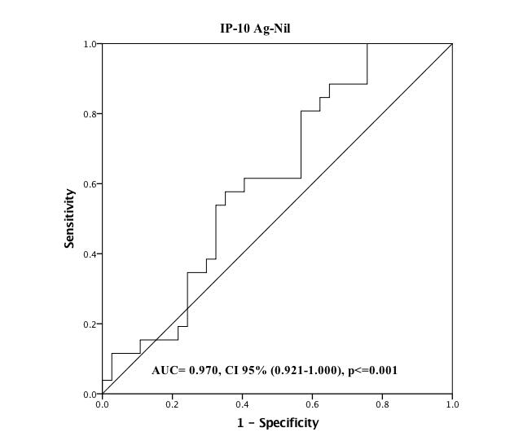
2c.
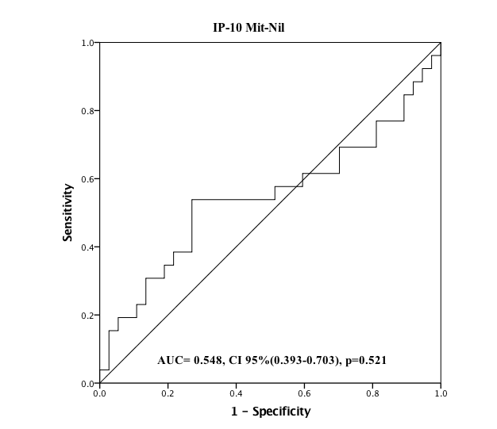
Figure 2. (a) Area under the curve of Unstimulated (Nil) IP-10, (b) Antigen-stimulated (Ag-Nil) IP-10, and (c) Mitogen-stimulated (Mit-Nil) IP-10 for diagnosis of TB infection in children. IP-10= IFNγ inducible protein 10, TB= Tuberculosis, AUC= Area under the curve, CI=confidence interval.

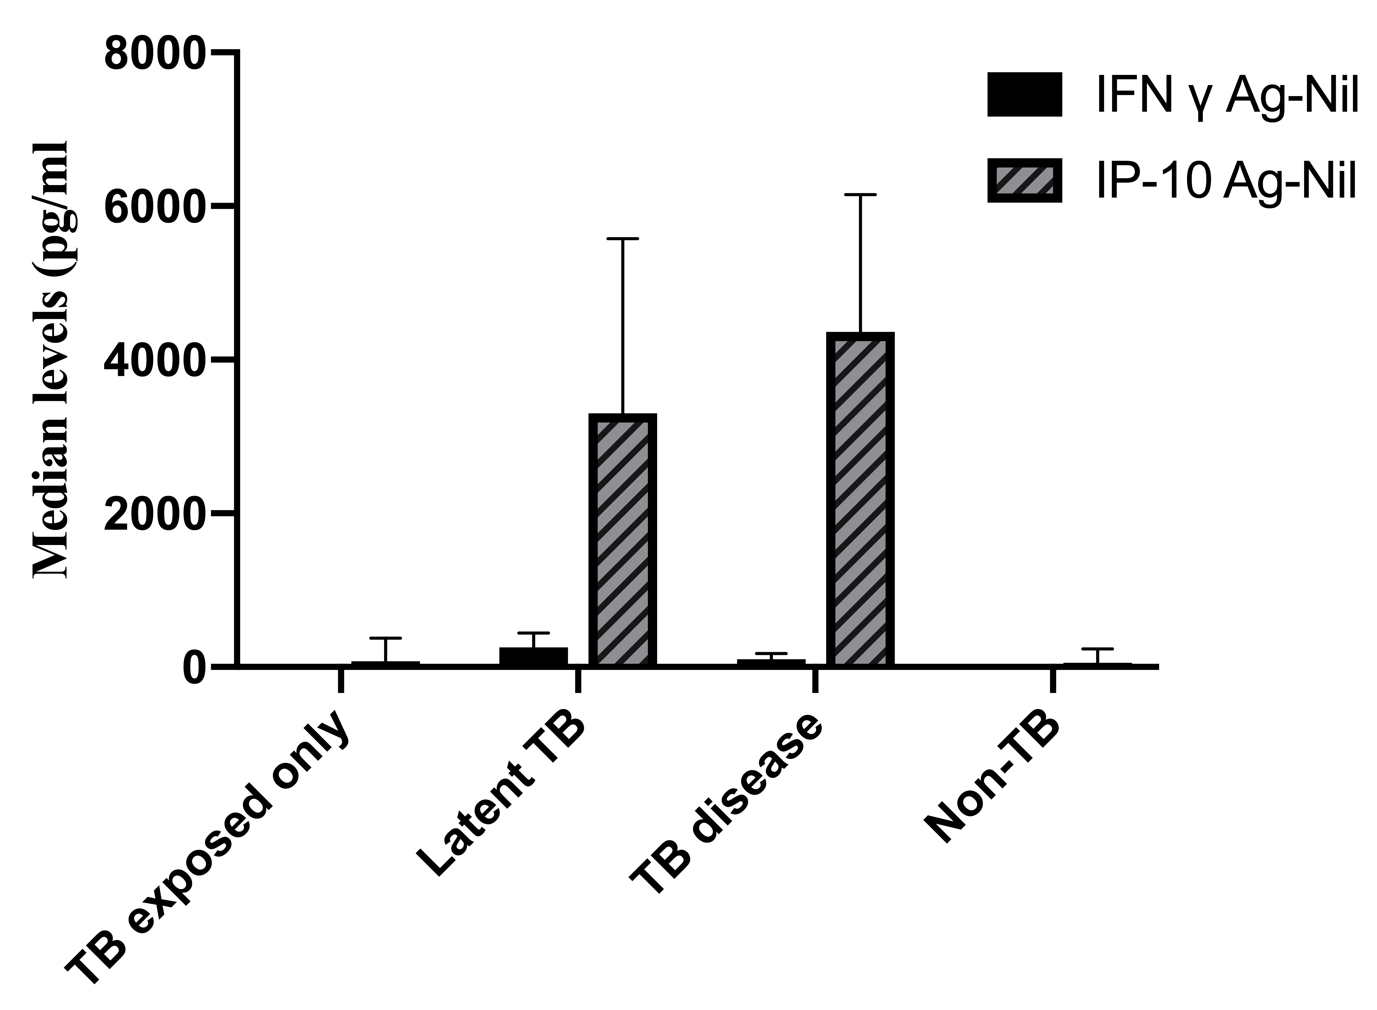
Figure 3. The comparison between median level of antigen-stimulated IP-10 and IFNγ among children with TB exposed only, latent TB, active TB, and Non TB. IP-10= IFNγ inducible protein 10, TB= Tuberculosis

Table 1. Characteristics of the children
Characteristics | N = 79 (%)
Sex, male | 42 (53.2)
Age, y
< 0-4 | 33 (41.8)
≥ 5 | 46 (58.2)
Close contact to adult TB | 68 (86.1)
asymptomatic | 58 (85.3)
symptomatic | 10 (14.7)
Nutritional status
Well-nourished | 61 (77.2)
Moderate wasting | 18 (22.8)
Severe wasting | 0
BCG vaccination | 79 (100)
BCG scar | 64 (81)
TB= Tuberculosis, BCG= Bacillus Calmette Guerin

Table 2. The IP-10 levels (pg/mL) in response to unstimulated, TB antigens, or mitogen

 | TB exposed only (n=37) | LTBI  (n=16) | TB disease  (n=10) | Non-TB  (n=7) | P value*
IP-10 Nil | 259.74 | 321.97 | 371.10 | 516.46 | 0.338
IP-10 Ag | 438.92 | 3705.87 | 4815.78 | 576.38 | ≤0.001
IP-10 Mit | 1938.96 | 2571.65 | 2308.76 | 2858.08 | 0.784
IP-10 Ag-Nil | 73.62 | 3304.30 | 4364.44 | 59.92 | ≤0.001
IP-10 Mit-Nil | 1554.06 | 2227.81 | 2048.05 | 2204.48 | 0.816
* Kruskal-wallis. TB= Tuberculosis, LTBI= latent TB infection, Nil= unstimulated, Ag= antigen, Mit= mitogen

